**Chapter 6: TRANSACTION**

**Transaction**

* In simple terms, **anything under execution** can be known as ***transaction***.
* Note how the definition matches to that of a **process**.
* In broader terms, **transaction** is a **group of SQL statements** that are executed in sequence.

**ACID Properties of Transaction**

* **Atomicity**
* **Consistency:** The database **works stable** & is **not** negatively affected by transactions.
* **Isolation:** One transaction **doesn’t** affect another running transaction.
* **Durability:** The affects of transactions **must be saved** to the database.

Atomicity:-

* For example, consider a transaction from **account** **A** to **account** **B**.
* **Account A** sends **$100** to **account B**, which results in **$100** being deducted from **A**.
* But some error occurred & **account B** didn’t received money.
* So, **$100** is added back to **account A**.

Consistency:-

* The **variables** involved during transaction must be **updated**.
* Database must have maintained **consistency** after & before each transaction.
* Maintaining consistency means **being in stable state**.
* It must **show the effect** of transaction in all the involved accounts.
* For example, the sender’s balance after deduction & receiver’s balance after addition must be updated.

Isolation:-

* Transactions have **no** information about other transactions running with them.
* Suppose many transactions named **A**, **B**, **C** & **D** are running **parallelly**.
* None of them have information about any other while they are transacting.
* But **C** got **committed** after completing its transaction, then **A**, **B** & **D** are updated with this information only during their transaction.

Durability:-

* Changes made to database after a transaction **must be saved**.
* Changes must **remain saved** even if the system fails (**reliability**).

**Transaction State Diagram/ Life Cycle**

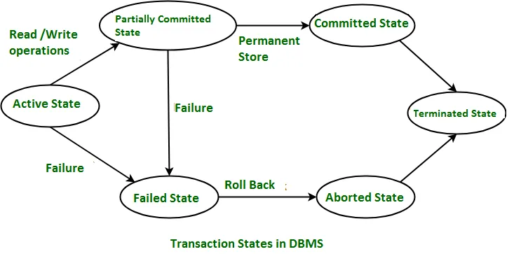

* We **can’t** rollback after a transaction is committed.

**Transactional Operations**

Read (X):-

* Used for **accessing** the requested data.
* The requested data is **first accessed** & **then loaded** into the main memory before being shown to the user.

Write (X):-

* Used for **modifying** the data.

**Transaction Scheduling**

* Operations of a transaction are **grouped** & **ordered**.
* **Schedule:** A sequence in which a group of operations are to be executed.
* They are sequenced because they can **affect each other** otherwise.
* For example, **updating** & then **reading** a data, or **reading** & then **updating** a data.
* The sequence of what to do first among the two is programmed as per the requirements.

**Types of Transaction Scheduling**

* Serial schedule
* Interleaved schedule
* Serializable schedule

Serial schedule:-

* Transactions are executed **serially**.
* A transaction **can’t** start until its previous transaction is **active** & **hasn’t** **committed**.

Interleaved schedule:-

* Active transactions can be **interrupted** by other transaction.

**Serializability**

* Transactions are executed **concurrently/parallelly**.
* But they **maintain the consistency** of database.

**Types of Serializability**

* Conflict serializability
* View serializability

Conflict serializability:-

* An operation each from two different transaction are executing.
* Let’s call these operations as **o1** and **o2** respectively.

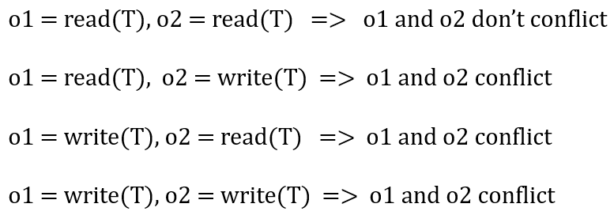

* So, a conflict exists only when **atleast one** of the multiple operations is **write**.
* But if they are working on **separate data**, then it is **not conflicting**.
* If two **non-conflicting** group of operations can be **swapped** & that makes it **serially scheduled**, then we call it ***conflict serializability***.

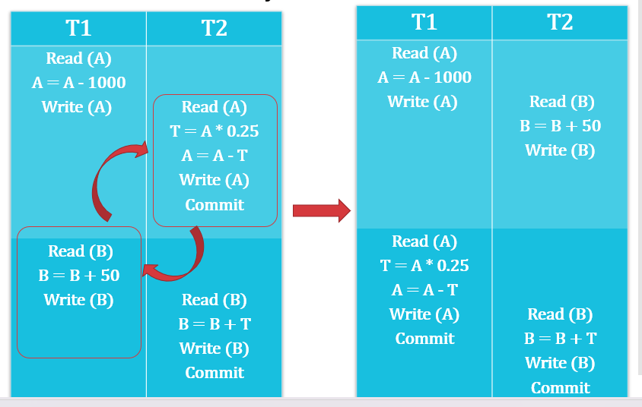

View serializability:-

* Let there be **two schedules** with same set of transactions.
* They are called ***view serialized*** when they satisfying these conditions:
  + Initial read
  + Updated read
  + Final write
* And these operations are done on same data variable.

Initial read:-

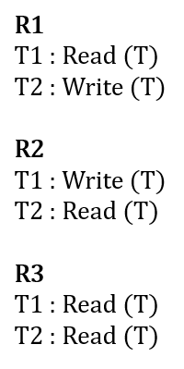

* **View equivalent:** Following view serializability protocols.
* **R1** and **R2** are **not** **view equivalent** because in **R1**, **T1** is reading initially & in **R2**, **T2** starts reading initially.
* But **R1** and **R3** are view equivalent because in **T1** reads in both initially & at ending.

Updated read:-

* In a schedule **R1**, if a transaction let’s say **T1** reads a data **X** **most recently** updated by another transaction **T2**.
* And in **R1**, if transaction **T1** reads the same data **D** again **most recently** produced by transaction **T2**, then schedule **R1** & **R2** are **view equivalent**.

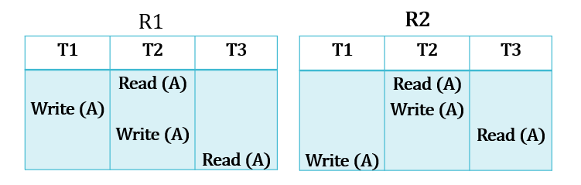

* For example, see above how in schedule **R1**, **T3** reads **A** which was **most recently** updated by **T2**.
* And the same is happening in schedule **R2**.

Final write:-

* In a schedule **R1**, if transaction let’s say **T1** performs the **final write** operation on data **X**.
* And in schedule **R2**, if same transaction **T1** performs the **final write** operation on same data **X**, then schedule **R1** & **R2** are **view equivalent**.

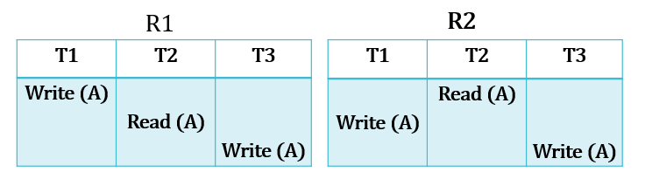

* In the example above, **R1** and **R2** are **view equivalent**.

**Two Phase Commit Protocol (TPCP)**

* ***TPCP*** ensures that all **nodes**, each having a database are **synchronized** together.
* And thus, the data are **updated altogether** being synced.
* In **TPCP**, there is a ***coordinator/ controlling node*** & rest are known as ***cohorts/ participants/ slaves***.
* **Coordinator** sends request to **commit** a transaction.
* **Cohorts** tell if transaction must be **committed or not** & acknowledge commits.
* Here, 2 phases are involved:
  + Prepare phase (preparation for commit)
  + Commit or abort phase

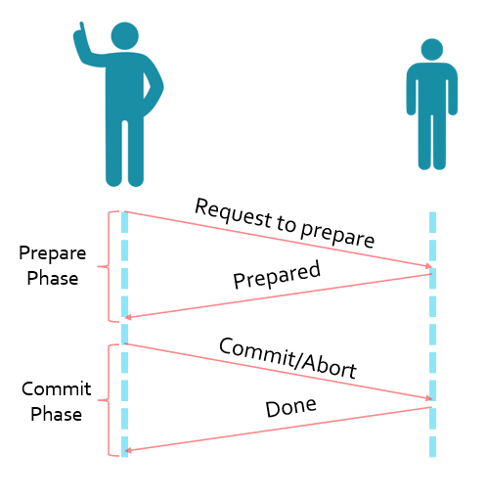

Prepare phase:-

* After each **cohort** is done with their transactions, each of them sends a **DONE** message to the **coordinator**.
* After receiving it from each of them, **coordinator** sends a **PREPARE** message to each **cohort**.
* This **PREPARE** message means **"prepare to commit"**.
* If a **cohort** wants to commit, it sends a **READY** message.
* Else, it sends a **NOT READY** message.

Commit phase:-

* After the **coordinator** receives commit message from all **cohorts**, coordinator sends a **GLOBAL COMMIT** message to all the **cohorts**.
* Then the **cohorts** commit the transaction & send **COMMIT ACK** message back to the **coordinator**.
* If the **coordinator** has received **COMMIT ACK** message from each **cohort**, then the transaction can be said to be **completed**.
* When the **coordinator** receives **NOT READY** message from even a **single cohort**, then it sends **GLOBAL ABORT** message to all the **cohorts**.
* Then the **cohorts** **abort** the transaction & send **ABORT ACK** message back to the **coordinator**.
* If the **coordinator** has received **ABORT ACK** message from each **cohort**, then the transaction can be said to be **aborted**.

**Database Recovery**

* In some situations, a transaction might **not commit or abort** successfully.
* These situations include:
  + Disk failure
  + DBMS crash
  + OS crash
  + Power failure
* It leads to ***data inconsistency*** (data loss) as when **partial SQL script** is executed, all the changes are **not** saved.

**Log Based Recovery**

* **Log:** **Record** of all the activities or operations performed on the database.
* Log contains:
  + **Start of transaction**
  + **Transaction ID**
  + **Record ID**
  + **Type of operation** (insert, update & delete etc)
  + **Old value**
  + **New value**
  + **Transaction status** (committed/aborted)

For example:-

**T1 transaction starts = <T1 Start>**

**Write operation by T1 = <T1, X, D1, D2>**

**X = Variable name**

**D1 = X’s value before transaction**

**D2 = X’s value after transaction**

**Types of Log-Based Recovery**

* Immediate database modification
* Deferred database modification

Immediate database modification:-

* **Auto committed**, so done **without** the commit command.
* In case the transaction fails, the transaction is **restarted**.

Deferred database modification:-

* Commit command must be written **explicitly**.

**Checkpoints**

* In checkpoint-based systems, you know what happens very well.
* And it has **nothing** to do with commit command.

**Shadow Paging**

* Another database recovery method.
* Used in case of **serial transactions** only.
* There are **two page-tables** in this system.
* They are called **current page table (CPT)** & **shadow page table (SPT)**.
* Database is divided into various **fragments/pages**.
* **CPT** contains the **current fragment/page** of database.
* Whereas **SPT** contains **all fragments** of database.
* Basically, **CPT** is the one user makes changes on & **SPT** just **points** all of them.
* When a change is made on a **fragment/page**, a new copy with changes is created.
* And the **CPT** points to **new copies** & **SPT** continues pointing old pages.
* Thus, in case of **recovery**, the old pages can be recovered via **SPT**.

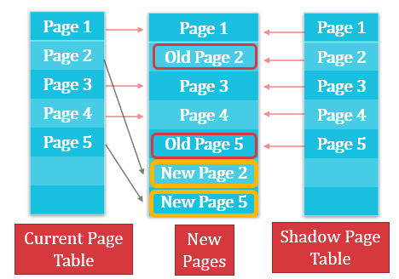

**Cascading Rollback**

* It’s a **rollback** performed when a transaction fails.
* This causes other transactions to **rollback too** which are related to the rolled transaction.

For example:-

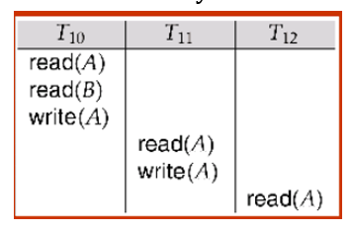

* Notice how **T11**& **T12** are dependent on **T10**.
* **Cascadeless schedule:** A schedule in which a transaction **isn’t** **allowed** to make operation on data which was used in another transaction but **not** committed.

**Concurrency Control**

* Required in **multi-user system**.
* Manages **simultaneous operations** on same data by different transactions.
* When **multiple** transactions make operation on **same data**, then **concurrency control** decides which transaction’s operation will be accepted (**mutual exclusion**).
* This conflict is either **read-write** or **write-write**.

Problems with concurrency controls:-

* **Lost update:** If two transactions write on a data, then the update by **T1 transaction** will be overwritten by the **T2**.
* **Dirty read:** When a transaction **T1** updates an item the **wrong way** **&** **fails**, meanwhile another transaction **T2** does operation on same data which now has **wrong value**.
* **Incorrect retrieval:** When a transaction **T1** makes series of operations on a data, meanwhile another **transaction T2** makes changes to that data, making remaining operations by **T1** **useless**.

**Lock Based Protocols**

* **Locking protocol:** Protocol followed by all transactions while **locking** & **releasing** locks on themselves.
* **Lock:** A variable used to provide **concurrent access** to transactions on a data item.
* These are of two types – **Exclusive (X) mode** & **Shared (X) mode**
* **Exclusive (X) mode:** Data item can be both **read** & **written** but by only one transaction at a time.
* Uses **lock-X** instruction.
* **Shared (S) mode:** Data item can **only be read** but by multiple transactions simultaneously.
* Uses **lock-S** instruction.
* In a system of transactions where all hold a lock, **all** can have a **shared lock**.
* But if **even a single** of them have an **exclusive lock**, **no** other transaction can have any lock on it.
* If a transaction is **not** being granted lock, then it waits until locks that are blocking its access **release** themselves.

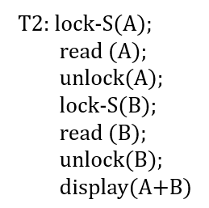

* Before execution, two separate **lists** are created.
* **L1** containing **data items** & **list L2** containing types of **locks**.
* Then during the transaction, as per the codes; **one-to-many** relations are made between **L1**and **L2**.
* Once its first lock gets released, then **no** other lock is granted until all of the remaining locks are **released**.

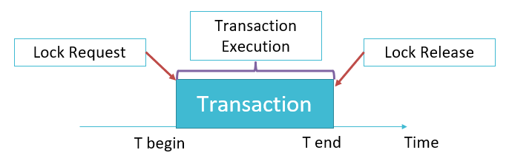

**Two Phase Lock Protocol**

* **Growing phase:** Transactions **can** **acquire** lock, but **can’t** **release** them.
* **Shrinking phase:** Transactions **can** **release** lock, but **can’t acquire** them.
* This protocol ensures that locks are **serially** acquired & released.
* **Lock point:** A point where a lock was made.

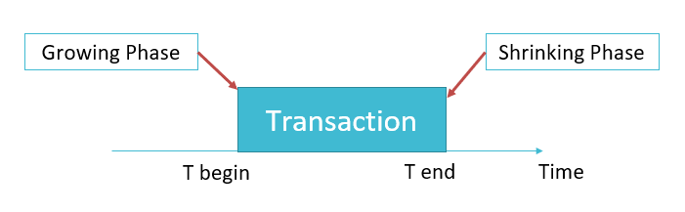

* During **growing phase**, when a transaction with **lock-S** tries acquiring **lock-X**, then **lock-S** is converted into **lock-X**.
* And during **shrinking phase**, when a transaction with **lock-X** releases the lock, then **lock-X** is converted **back** to **lock-S**.

Strict two phase locking protocol:-

* **Exclusive locks** can’t be released until **committed** or **aborted**.
* Other transactions can only acquire **shared lock** on common data item.

Rigorous two phase locking protocol:-

* Neither **exclusive** nor **shared locks** can be released until **committed** or **aborted**.
* Other transactions **can’t** acquire even a shared lock on common data item.

Drawbacks of two phase lock based protocol:-

* Programming error can cause a **deadlock**.
* And deadlock causes **starvation**.

**Intention Locking**

***\*In reference to tree shaped database\****

* **Intention-shared (IS):** Shared locking around **root node** of the tree.
* **Intension-exclusive (IX)**
* **Shared and intention-exclusive (SIX):** Mixed

**Multiple Granularity**

* A concept in **concurrency control**.
* Data items are represented in form of **tree**.
* When a **parent** is **locked**, its **children** are **automatically locked** too.
* To get lock on a child, **none** of its parent node must be locked.

Lock implementation:-

* **Lock manager:** Manages lock requests.
* It responds saying either **LOCK GRANTED** or **WAIT**.
* **Lock manager** stores all the **records** of locks (granted & to be granted) in a ***lock table***.
* This record is in the form of a **queue**.

Time stamp-based protocol:-

* Each transaction is issued a ***timestamp*** when they enter a system.
* For example, **timestamp** for **T1** will be **TS(T1)**.
* **Older** **timestamps** are given priority for being executed.
* **W-timestamp(Q):** Largest **write** timestamp out of all transactions.
* **R-timestamp(Q):** Largest **read** timestamp out of all transactions.

Suppose **Read(Q)** by **T1**:-

* If **TS(T1) <= W-timestamp(Q)**, then **read** operation is **rejected** because **write** operation is **active**.
* If **TS(T1) >= W-timestamp(Q)**, then **read** operation is **granted** because **write** operation is **done executing**.
* If **TS(T1) <= R-timestamp(Q)**, then **write** operation is **rejected** because **read** operation is **active**.
* If **TS(T1) >= R-timestamp(Q)**, then **write** operation is **granted** because **read** operation is **done executing**.

**Deadlock**

* A solution to **deadlock** is to **roll back transaction** when resource is **not** available & **come back later** to check the availability of the resource.

Deadlock conditions:-

* **Mutual exclusion:** One process/transaction accesses a resource at a time.
* **Hold and wait:** A transaction **holds** one resource & **waits** of other resources which are held by other processes.
* **Non-preemption:** No process to **pre-empt** a process stuck in a deadlock.
* **Circular wait:** A deadlock in which all transactions are **circularly waiting** for each other.
* For example, in **{T1, T2, T3}**, **T1** waits for **T2**, **T2** waits for **T3** & **T3** waits for **T1**.

Deadlock detection:-

* It can be done using ***wait-for graph***.

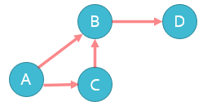 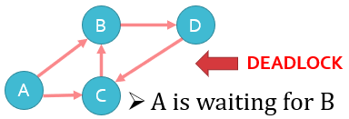

* **Directed edge**, for example from **A** to **B** means that **A** is **waiting** for a resource held by **B**.
* Any **cyclic pattern** observed means a **deadlock** is formed (refer to figures above).

Deadlock recovery:-

* As discussed earlier, a simple way to **recover** from deadlock is by **rolling back**.
* **Victim:** Transaction which incurs **minimum loss** & thus rolled back.
* **3 conditions** to roll back a transaction:
  + Transaction has **minimum locks**.
  + Transaction has **executed very less amount of work**.
  + Transaction **won’t be completing sooner**.

**Deadlock Prevention**

Wait-die approach:-

* An **older transaction** **waits** for the **younger transaction** to **release** the resource.
* But if **younger transaction** **waits** for an **older transaction** to **release** the resource, then the **younger transaction** is **rolled back**.

Wound-wait approach:-

* An **older transaction** **forces** the **younger transaction** to **release** the resource.
* But the **younger transaction** **waits** for the **older transaction** to **release** the resource.

Timeout-based approach:-

* A transaction is given the resource only for a **fixed duration** of time.
* After the time expires, it is **rolled back**.